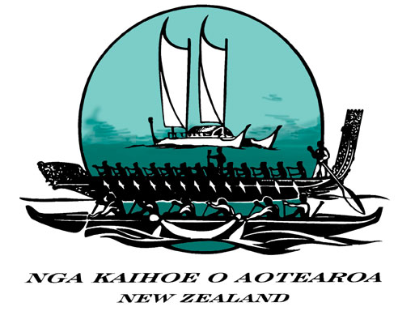

NKOA Waka Ama High Performance Development Programme

What is the HPD Programme?

NKOA is in the process of setting up the HPD programme. Following our success at the 2006 World Championships, the aim now is to move forward in establishing structures and processes that will consolidate and further improve New Zealand’s status as a leading force in waka ama.

The HPD Committee

NKOA has set up a High Performance Development Committee. The Committee comprises:-

Co-ordinator Peter Reaburn
NKOA Rep Maggie Greening
TTCPA Rep Rob Gable
AROCA Rep Ray Tonkin
TPTOI Rep Howard Hyland
TUOTR Rep Kapua Waikari
Hoe Tonga Rep Charmaine Matiaha
SI Rep Shaun Hardcastle

Initial Objectives

The initial meeting of the committee was held in Gisborne on 25 November 2006. The committee discussed a number of matters, with the main conclusions reached being:-

- The focus of HPD should be on the elite level of the sport
- Sprint and Long Distance paddling should be supported
- Rather than a national coach, there should be a National HPD Convenor. This position should be responsible for national organisation and support of HPD programmes, including at the regional level
- Adminstrative support is also required
- A coaching standards system is necessary (similar to initiatives being pursued in Australia)
- Preparation of a Waka Ama coaching manual should be a priority
- For international sprint events, a process based on the 2006 Worlds should be adopted
- For international Long Distance events, a process needed to be devised. This will not necessarily be based on the same process as for sprints
- An international event in Aotearoa should be established on the international calendar, with the aim of achieving the same status as Molokai, Hawaiikinui and Hamilton Island
- There may be an overlap between the sprint and long distance paddling seasons.

Following this meeting there was further discussion and development of a framework for HPD development, which will progressively be put in place over a two year period.

Resources

The important first step is appointment by NKOA of the National HPD Convenor. A job description for this position is currently being prepared. The position will be advertised in August 2007. In the meantime, the HPD Committee will use its own resources to develop the initiatives required to progress the HPD programme.

2008 World Sprints – Sacramento

As was the case for 2006, all individuals and teams attending the 2008 World Sprints will be national representatives and will need to be selected as part of a national programme. In other words, it will be compulsory for intending participants to follow the programme as set up by NKOA.

No paddler will represent New Zealand at the 2008 World Sprint Championships without entering the NKOA selection process. Initial emphasis will be placed on assessments of individual paddler ability. W1 trialling will be part of this process.

As in the 2006 selection process, no paddler will be disadvantaged through not being in a top club team. Similarly, no paddler will be advantaged by moving clubs to be in a better performing team. Paddlers with ability will have the opportunity to be selected, wherever they come from. NKOA considers it very important that club paddling is not compromised by national selection processes.

Two differences from the 2006 process will be that more emphasis will be placed on paddling skills, and the process will be more centralised, rather than the four distinct divisional programmes used last time. There will still be four divisions, but they will be more coordinated. The National HPD Convenor, once appointed, will have an important role in organising the new process.

The process will begin with a call for interest from paddlers in August 2007.

Expressions for interest in Coaching/management appointments will also be called for in August 2007 and appointments will be confirmed by 30 September 2007.

2007

August Call for expressions of interest from Coaches and Paddlers
30 September Appointment of coaches

2008

30 June Final Squad Selection
31 July Leave for Sacramento
8 Aug Start of World Champs

The remaining timeframes for the selections will be communicated to paddlers after the coaching / management team is appointed.

There will be many questions relating to whether there will be funding support, etc that will be able to be answered later this year. NKOA is assuming that there will be no funding available, however are committed to pursuing funding avenues.

2008 Sprint Nationals

The 2008 Sprint Nationals will proceed as a club championships.

Regional Sprint Nationals

The tentative event set down for earlier this year was cancelled. The date for the regional championships is 29 – 30 March 2008 at Karapiro.

Long Distance Events

The initial thinking is that two women’s and two men’s teams (one open, one masters) will be selected as national representatives to a major international event in the year that does not include a World Sprints – the first such year being 2009. This will be confirmed later this year when the selection process will be developed.

The selection process will differ from the sprint process. Expressions of interest of national long distance coaches for men and women will be called for in September 2008 for the 2009 LD selection.

This does not exclude any team from competing internationally, the intent is to select nationally representative team.

Next Steps

The HPD Committee will keep regions, clubs and paddlers informed of progress on all these initiatives. If you have any feedback please contact your nearest HPD representative or email Peter at peterr@catobolam.co.nz

