Hauraki Hoe 2007 Panui 1

The 2007 Hauraki Hoe is being run in conjunction with the Pasifika Festival hosted by Auckland City Council, Manukau City Council and Waitakere City Council; and is supported by the Northcote Community Centre and North Shore City Council.

This year the course will be run in reverse to maximise the benefit to spectators and to meet the needs of the local community. Starting from Birkenhead wharf, going up the harbour, out around Motuihe Island, running across to the back end of Motutapu Island, around Rakino, across the back of Motutapu and Rangitoto Islands, crossing the channel to North Head, and up the harbour to finish at Birkenhead.

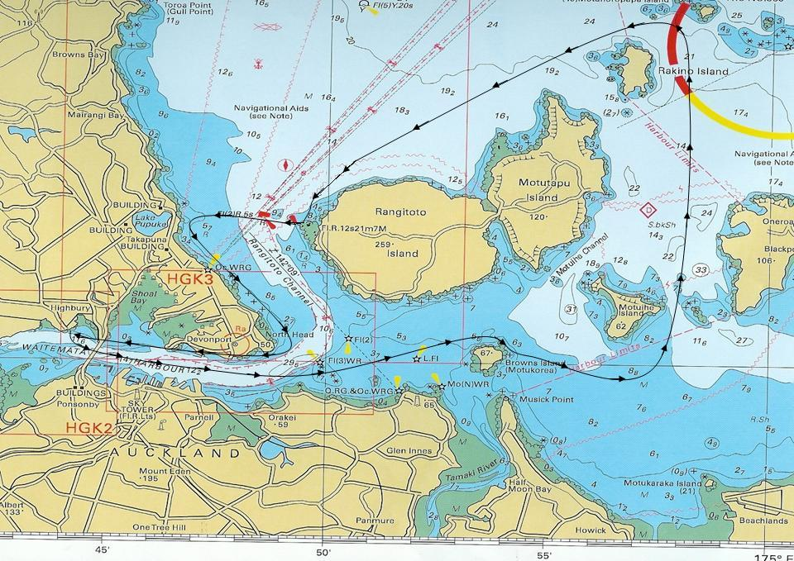

There will be a Junior Hoe Potu ("mini Hoe"), open to J16 & J19 crews with water changes, being run out of Little Shoal Bay with full spectator viewing from the shore. The course will be approximately 8 circuits of a 12min loop with crew changes at the completion of each circuit. It is anticipated the course will be a circuit out from Little Shoal Bay, to the Red Channel marker, across to Rauwaka (formerly Fisherman’s Wharf) and back into Little Shoal Bay with crew changes happening in Little Shoal Bay, subject to sufficient water in the bay.

There will be on shore activities for the whole family, an awards ceremony, dinner and music. Put it in your diaries now, start training and sign up on line at www.haurakihoe.co.nz to take part.

The draft of the race programme and accommodation information is on the web site.

The 2007 Hauraki Hoe will be an event to remember!!

