Long Distance Nationals Update

5th & 6th May
Narrow Neck Beach, Auckland

This is an update to the original Panui which can be found under the Upcoming Regattas listing for this event.

J16
After careful consideration the race committee have agreed to accept J16 paddlers to paddle in the J19 division. There will be very close monitoring of conditions and paddler capability. If there is any doubt about a paddler / teams ability to cope, the Race Director has total authority to pull a team off the water. The Race Directors decision will be final, discussions/negotiations will not be entered into.

Entries Extension
It has been agreed that entries will be further extended until midday on the 3rd May. Payment must lodged by same date. Please e-mail entries to Jan Nicholson - jan.nicholson@janal.co.nz
Check the LDN regatta listing to get the account details and your deposit reference code. There is a unique code for each Club. Please ensure you use it as unidentified deposits will be Koha !!!

Race Course
All races will start and finish at Narrow Neck Beach, hugging the bays on the way up and straight line back to the finish :

10km – will turn on a 5km buoy off Milford (Black line)
15km – will turn on a 7.5km buoy off Castor Bay (Green line)
28km – will turn on a 14km buoy off Toroa Pt (between Long Bay & Torbay) (Red line)
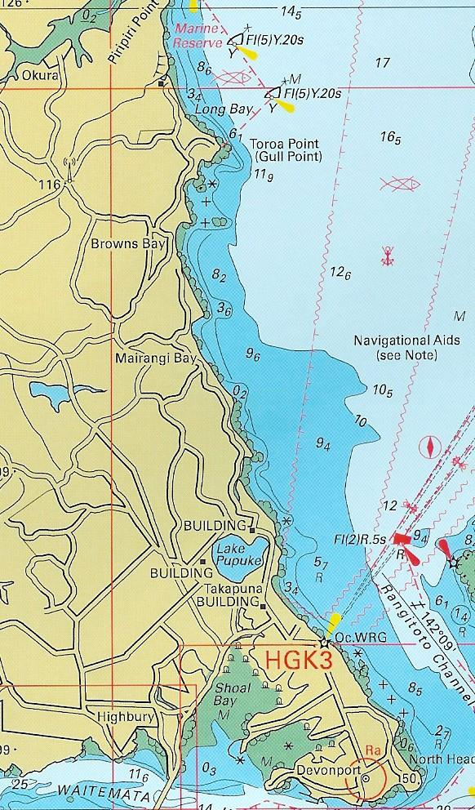

Registration
All paddlers MUST produce their paddler Id card when they register for their race.

Race Programme

Friday – W1 & W2

8:30am - Opening
9:00am - J19 W1 & W2 race briefing
10:00am – J19 Race Starts

11:30am – Women W1, W2 & Mixed W2 race briefing
12 noon – Women and Mixed Race Starts

1:30pm – Men W1 & W2 race briefing
2:00pm – Men W1 & W2 Race Starts

Saturday

8:00am – J19 W6 race briefing
8:30am – J19 W6 Race Starts

10:00am – Women & Mixed W6 race briefing
10:30am – Women & Mixed W6 Race Starts

1:30pm – Men W6 race briefing
2:00pm – Men W6 Race Starts

Saturday Night Function & Medal Ceremony
The medal ceremony will be conducted at Watakere Yacht Club (where racing is held) from 6pm. The function will be held at the same venue. Dinner from 7pm. There will be Music & a Bar – you will need to purchase tickets on site to use at the bar. The bar will only exchange tickets for drink, not cash.

Waka
W1 waka will be weighed up to 16kg . Please bring along approved weights.
W6 waka will be weighed up to 130kg. Weights in kg increments are acceptable.
Check Panui 1 on the regatta listing for weighing times.
Spray skirts – mandatory for all waka W1, W2 & W6, except sit on style.
For more information please refer to NKOA LD race rules 43.0 to 52.0

Clothing
Ensure you dress appropriately for the changeable conditions. A singlet will not be adequate. Ensure you at least have a polyprop on under whatever top you decide to paddle in. It can turn very cold and choppy very quickly. Also make sure you have plenty of warm gear to wrap up in when you come off the water. Like Karapiro at the Worlds, we can have 4 seasons in one day - quite often.

Contacts :

Liz Portas – ELIZABETH.PORTAS@nzdf.mil.nz

Jan Nicholson – jan.nicholson@janal.co.nz

