In loving memory of

Nathan “NATEDAWG” Maurice Portas

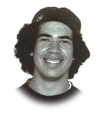

15th August 1988 – 11th August 2005

Liz, Gary, Nicole and Renee Portas thank all the wakaama whanau throughout Aotearoa for the many messages, love, support and contributions you have all shown and given us during the recent loss of our only son and brother Nathan.

We ask everyone to think of the good/happy times and achievements Nathan accomplished in his short time on this earth and to cherish those memories.

His reason for leaving us will never be known but his memories he has left us will always be treasured.

“Ka whati ra ia taku mahuri totara”
My totara sapling so suddenly broken off

